Đề trial

I. CASE STUDY
Green University is a mid-sized institution with approximately 8,000 students and 400 academic staff. Each semester, the university must manage course enrollment for all undergraduate and postgraduate programmes. Currently, students submit paper-based registration forms to their faculty office, and clerks manually enter the data into spreadsheets. This process is error-prone, slow, and creates long queues during the registration window. The university's administration has therefore decided to commission a web-based Course Registration System (CRS) to automate and streamline the entire workflow.
The CRS is expected to serve four main groups of users. Students need to browse the catalogue of available courses, check their eligibility based on completed prerequisites, submit registration requests, and track the status of each request in real time. If a course is fully booked, a student may join an electronic waitlist; should a registered student later drop the course, the system automatically notifies and enrolls the first eligible student on the waitlist. Lecturers need to review the roster of students enrolled in their courses, record midterm and final grades, and release grades to students once the grading period closes. Academic Staff (administrators) are responsible for defining the semester timetable, setting and publishing course quotas, opening and closing the registration window, approving exceptional cases, and generating enrolment and grade-distribution reports. Finally, a System Administrator manages user accounts, configures system parameters, and oversees scheduled data backups.
From a technical standpoint, the university imposes several constraints. The system must remain responsive—handling at least 1,000 simultaneous users during peak registration periods with a page-response time under 3 seconds. Because student records and grade data are sensitive, all communication must be encrypted using TLS 1.2 or higher, and access must be governed by a role-based access control (RBAC) model so that each user sees only the functions and data relevant to their role. The platform must be available 99.5 % of the time during the semester, with any planned maintenance scheduled outside the registration window. The interface must be accessible on both desktop and mobile browsers and must conform to WCAG 2.1 Level AA accessibility standards. The architecture should also support horizontal scaling so that additional server capacity can be added smoothly as student numbers grow in future years.

Question 2: UC Modeling (1.5 points)
- Identify ALL actors in the Course Registration System. For each actor, state their primary goal and whether they are a primary or secondary actor. (0.3 points)
- List at least EIGHT use cases for the CRS. For each use case, state the initiating actor(s) and a one-sentence description of the goal. (0.4 points)
- Draw a complete UML Use Case Diagram for the CRS. The diagram must include: (0.8 points)
  - All identified actors, placed correctly inside or outside the system boundary
  - All major use cases inside the system boundary rectangle
  - At least ONE <<include>> relationship — provide a brief written rationale
  - At least ONE <<extend>> relationship — provide a brief written rationale
  - Any actor-generalisation relationships that apply

Cách làm

- Identify All actors

Actor | Type | Goal
Students | Primary | Register for courses, track status, join waitlist
Lecturers | Primary | View class roster, input grades and publish grades
Academic Staff | Primary | Manage timetable, quotas, approve exceptions
System Administrator | Primary | manages user accounts, configures system, back up data
Notification system | Secondary | Send automated notification for waitlist

2, Liet ke use case

ID | Use case | Initiating actor | Goal
1 | Browse course catalogue | Student | View course list and detail
2 | Check prerequisites | Student | Check condition before registration
3 | Submit registration request | Student | Register for a specific course
4 | Join waitlist | Student | Register when the course is full
5 | Track registration status | Student | View status
6 | View enrolled roster | Lecturer | View the list student enrolled the course
7 | Record grades | Lecturer | Input the midterm and final grades
8 | Release grades | Lecturer | Publish grades
9 | Manage timetable | Academic Staff | Create, update timetable
10 | Manage registration window | Academic Staff | Control open and close registration window
11 | Approve exceptions | Academic Staff | Manually approve special case
12 | Generate reports | Academic Staff | Export registration and grade distribution
13 | Manage user accounts | System Administrator | manages user account
14 | Send automated notifications | Notification system | Send email confirm
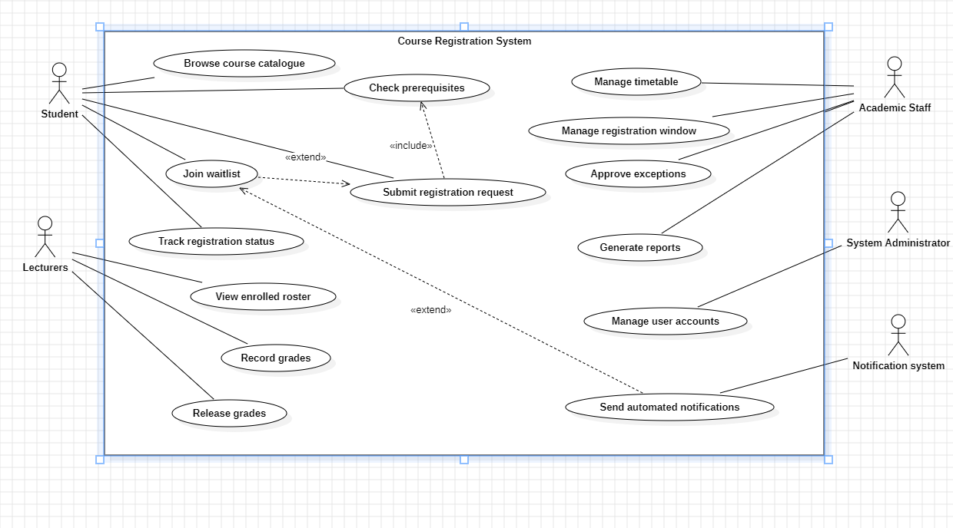

Bước 1: Xác định các thành phần (Analysis)
Trước khi vẽ, bạn cần liệt kê các thành phần dựa trên Case Study:
- Actors (Người dùng):
  - Student (Sinh viên)
  - Lecturer (Giảng viên)
  - Academic Staff (Nhân viên giáo vụ)
  - System Admin (Quản trị viên)
- Use Cases (Chức năng chính - ít nhất 8 cái):
  - Browse Course Catalogue (Xem danh mục môn học)
  - Register for Course (Đăng ký môn học)
  - Check Prerequisites (Kiểm tra môn tiên quyết) -> Quan hệ <<include>>
  - Join Waitlist (Vào danh sách chờ) -> Quan hệ <<extend>>
  - Input Grades (Nhập điểm)
  - View Roster (Xem danh sách lớp)
  - Define Timetable (Lập thời khóa biểu)
  - Manage User Accounts (Quản lý tài khoản)

Bước 2: Thao tác trên Draw.io
- Mở Draw.io: Chọn "Create New Diagram" -> "Blank Diagram".
- Kéo thả Actor: Ở cột bên trái (mục UML bạn đã thấy), kéo hình người (Actor) ra. Đặt tên lần lượt cho 4 Actor nêu trên.
- Vẽ System Boundary: Tìm hình chữ nhật (Frame hoặc Rectangle) kéo ra, bao quanh vùng giữa màn hình. Đặt tên là "Course Registration System". Tất cả các hình Oval sẽ nằm trong này.
- Kéo thả Use Case: Kéo hình Oval (Use Case) vào trong hình chữ nhật. Gõ tên các chức năng bằng tiếng Anh.
- Nối quan hệ:
  - Dùng đường kẻ thẳng nối từ Actor đến Use Case mà họ thực hiện.
  - Quan hệ Special: * Vẽ mũi tên đứt đoạn từ Register for Course tới Check Prerequisites, ghi chữ <<include>>. (Vì đăng ký là bắt buộc phải check môn tiên quyết).
    - Vẽ mũi tên đứt đoạn từ Join Waitlist về Register for Course, ghi chữ <<extend>>. (Vì chỉ khi lớp đầy mới thực hiện chức năng này).

Bước 3: Hoàn thiện bản tiếng Anh (Để đưa vào Answer Sheet)
Trong file Word, mục Question 2, bạn nên viết một đoạn ngắn trước khi chèn hình:
2.1 Identification of Actors and Use Cases:
- Primary Actors: Student, Lecturer, Academic Staff, System Administrator.
- Secondary Actor: Email System.
- Key Use Cases: Browse Catalogue, Register for Course, Join Waitlist, Input Grades, View Roster, Define Timetable, Manage Accounts, Authentication.
2.2 Use Case Diagram: (Tại đây, bạn chèn ảnh đã chụp từ Draw.io vào)

Bước 4: Cách xuất hình ảnh
- Trên Draw.io: Vào File -> Export as -> PNG.
- Mở file Word: Chọn Insert -> Pictures -> Chọn file PNG vừa lưu.
- Căn chỉnh hình ảnh cho rõ ràng, không bị méo.
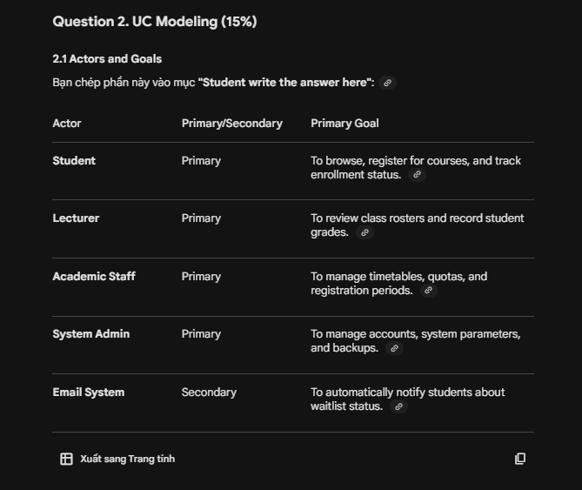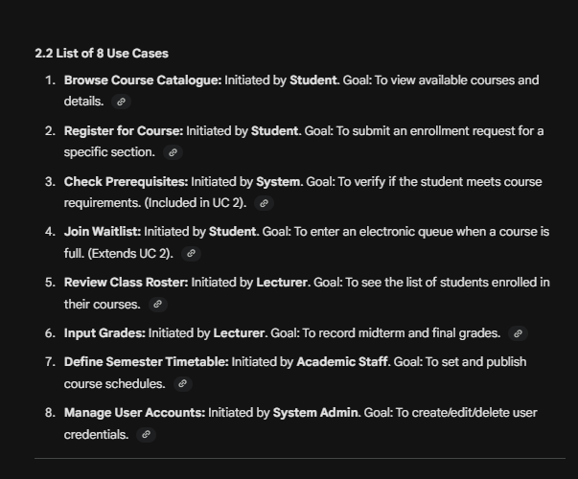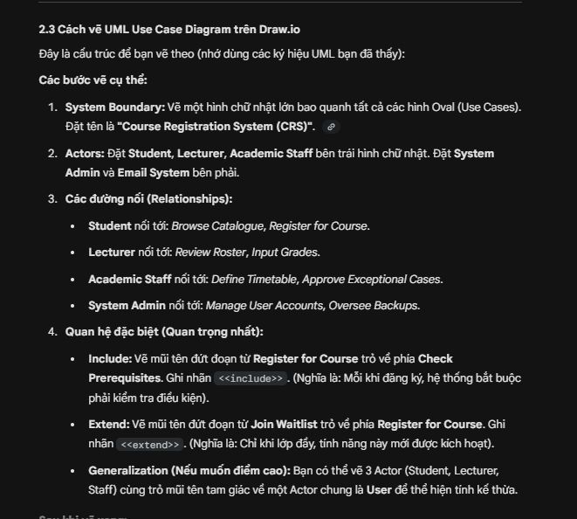
Đề ôn tập

PRACTICE TEST 1: E-COMMERCE & SMART LOGISTICS
I. CASE STUDY
"SwiftMart" is a rapidly growing online grocery platform currently struggling with a manual backend that leads to frequent delivery delays. The company has commissioned an "Integrated Fulfillment System" (IFS) to digitize its operations. Customers use the web and mobile platform to browse products, manage their shopping carts, and process payments. A unique feature is the "Subscription Mode," where customers can schedule recurring weekly deliveries; the system automatically generates these orders every Monday. Delivery Riders use a dedicated mobile interface to accept delivery assignments, navigate to customer locations using integrated maps, and update the order status to "Delivered." Warehouse Staff are responsible for inventory management, including updating stock levels and marking items as "Damaged" or "Out of Stock." When inventory for a high-demand item falls below a certain threshold, the system automatically triggers a "Restock Alert" to the Procurement Team. Managers oversee the platform by viewing real-time sales analytics, managing promotional discount codes, and handling customer refund requests for missing items.
Technically, the IFS must integrate with a third-party Payment Gateway and a Mapping Service API. The system must handle up to 5,000 transactions per hour with a sub-2-second response time for checkout. Security is paramount; all payment data must be PCI-DSS compliant. If a payment fails, the system offers an optional "Retry Payment" path. The system must maintain 99.9% uptime, as any downtime directly results in lost revenue.
Question 2: UC Modeling (1.5 points)
- Identify ALL actors in the IFS. For each actor, state their primary goal and whether they are a primary or secondary actor. (0.3 points)
- List at least EIGHT use cases for the IFS. For each use case, state the initiating actor(s) and a one-sentence description of the goal. (0.4 points)
- Draw a complete UML Use Case Diagram for the IFS. The diagram must include: (0.8 points)
  - All identified actors and major use cases.
  - At least ONE <<include>> and ONE <<extend>> relationship with rationales.
  - Any actor-generalisation relationships that apply.
Identify All actors

Actor | Type | Goal
Customers | Primary | Browse products, place orders, manage Subscription
Delivery Riders | Primary | Accept orders
Warehouse Staff | Primary | Manage inventory levels and item status
Managers | Primary | Sales analytics, managing promotional discount codes, and handle refund
Payment Gateway | Secondary | Process payment transactions
Mapping Service API | Secondary | Provide data to riders

2, Liet ke use case

ID | Use case | Initiating actor | Goal
1 | Browse Products | Customers | Find item to add to cart
2 | Manage Shopping Cart | Customers | Add, remove , update quantities before check out
3 | Pay | Customers | Payment and confirm
4 | Manage Subscription | Customers | Schedule, modify, automatically generates these orders every Monday
5 | Accept delivery assignments | Delivery Riders | View and accept assigned delivery task
6 | Use map | Delivery Riders | To find the road and navigate to customers
7 | Update the order status | Delivery Riders | Update the order status to "Delivered."
8 | Manage inventory | Warehouse Staff | Update status
9 | Mark items | Warehouse Staff | marking items as "Damaged" or "Out of Stock."
10 | View sale analytics | Managers | viewing real-time sales analytics
11 | Manage discount code | Managers | Managing promotional discount codes
12 | Handle refund | Managers | Handling customer refund requests for missing items.

PRACTICE TEST 2: HEALTHCARE MANAGEMENT SYSTEM
I. CASE STUDY
"CityCare Hospital" is upgrading its legacy paper records to a digital "Patient Portal & Clinic Management System" (PPCMS). Patients utilize the portal to book appointments, view their digital prescriptions, and download lab results. If a patient is unable to attend, they can cancel their appointment; if done within 24 hours of the slot, the system automatically offers the opening to the next patient on a "Priority Waiting List." Doctors use the system to review patient medical histories, record consultation notes, and issue electronic prescriptions directly to the hospital pharmacy. Nurses are responsible for checking patients in upon arrival, recording vital signs (weight, blood pressure), and updating the room occupancy status. Medical Records Officers manage the archiving of sensitive data and ensure all records comply with national health privacy laws. An external Insurance Provider System is linked to the PPCMS to verify coverage and process billing claims automatically after a consultation.
The PPCMS must be highly secure, utilizing Multi-Factor Authentication (MFA) for all staff logins. The system must support at least 200 concurrent medical staff users without performance degradation. As per legal requirements, the system must maintain a full audit log of every user who accesses a patient's file. The interface must be optimized for tablets, as doctors and nurses move frequently between wards.
Question 2: UC Modeling (1.5 points)
- Identify ALL actors in the PPCMS. For each actor, state their primary goal and whether they are a primary or secondary actor. (0.3 points)
- List at least EIGHT use cases for the PPCMS. For each use case, state the initiating actor(s) and a one-sentence description of the goal. (0.4 points)
- Draw a complete UML Use Case Diagram for the PPCMS. The diagram must include: (0.8 points)
  - All identified actors and major use cases.
  - At least ONE <<include>> and ONE <<extend>> relationship with rationales.
  - Any actor-generalisation relationships that apply.

PRACTICE TEST 3: SMART GYM & FACILITY MANAGEMENT
I. CASE STUDY
"IronTemple Gym" is transitioning to a "Smart Facility Management System" (SFMS) to handle its 3,000 members. Members access the gym by scanning a QR code generated by the app, book slots for group classes (like Yoga or HIIT), and track their personal workout logs. If a member reaches a 30-day "Attendance Streak," the system generates a "Free Protein Shake" voucher. Personal Trainers manage their client rosters, design custom workout plans, and schedule 1-on-1 coaching sessions. If a session is booked, the system sends an automated reminder via an external SMS Gateway. Front Desk Staff handle new membership registrations, process monthly fee payments, and sell gym merchandise. Maintenance Technicians monitor the status of cardio machines; the machines are equipped with sensors that automatically send "Error Reports" to the SFMS if a mechanical failure is detected.
The SFMS must ensure that all staff actions are governed by a Role-Based Access Control (RBAC) system. To ensure safety, the system must limit the number of active QR code entries to the gym's maximum capacity (150 people). The mobile app must be accessible for visually impaired users (WCAG 2.1 compliance). Data backups must occur every 24 hours to an off-site cloud server to prevent data loss.
Question 2: UC Modeling (1.5 points)
- Identify ALL actors in the SFMS. For each actor, state their primary goal and whether they are a primary or secondary actor. (0.3 points)
- List at least EIGHT use cases for the SFMS. For each use case, state the initiating actor(s) and a one-sentence description of the goal. (0.4 points)
- Draw a complete UML Use Case Diagram for the SFMS. The diagram must include: (0.8 points)
  - All identified actors and major use cases.
  - At least ONE <<include>> and ONE <<extend>> relationship with rationales.
  - Any actor-generalisation relationships that apply.

PRACTICE TEST 4: AIRPORT PASSENGER SERVICE SYSTEM
I. CASE STUDY
"SkyPath International Airport" requires a new "Passenger Service System" (PSS) to handle the surge in holiday travelers. Passengers use the PSS kiosks or mobile app to check-in for flights, select seats, and generate digital boarding passes. During check-in, passengers may optionally "Purchase Extra Baggage" if their luggage exceeds the standard limit. Check-in Agents (staff) use the system to verify travel documents, tag checked luggage, and handle special assistance requests (e.g., wheelchair access). Gate Agents manage the boarding process, scanning boarding passes and updating the flight status to "Departed." Flight Coordinators (administrators) are responsible for assigning gate numbers to incoming aircraft, updating delay information, and managing the daily flight schedule. The PSS must synchronize data in real-time with an external Global Distribution System (GDS) which holds worldwide flight and seat inventory.
The PSS is a mission-critical system requiring 99.99% availability; even 10 minutes of downtime can cause terminal-wide chaos. The system must process boarding pass scans in under 500 milliseconds to prevent queues. Security protocols require that all staff must perform a biometric scan (linked to an external Biometric Database) to log into the terminal. The architecture must be redundant, with failover servers located in a separate physical building.
Question 2: UC Modeling (1.5 points)
- Identify ALL actors in the PSS. For each actor, state their primary goal and whether they are a primary or secondary actor. (0.3 points)
- List at least EIGHT use cases for the PSS. For each use case, state the initiating actor(s) and a one-sentence description of the goal. (0.4 points)
- Draw a complete UML Use Case Diagram for the PSS. The diagram must include: (0.8 points)
  - All identified actors and major use cases.
  - At least ONE <<include>> and ONE <<extend>> relationship with rationales.
  - Any actor-generalisation relationships that apply.

